* **Server client transparent**
* **Trunk**
* **Create vlans in the server(which** will automatically go to the client but not the transparent)

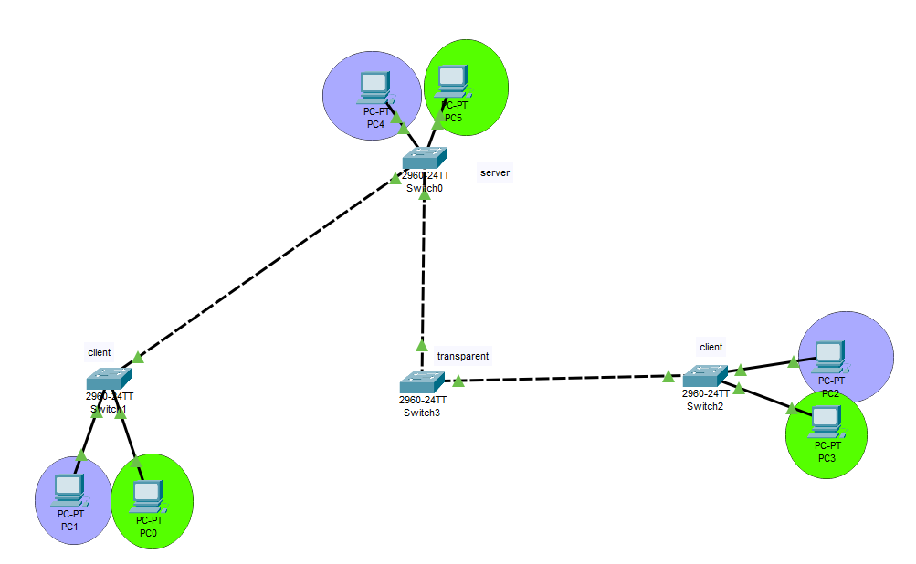

**SETTING UP STATUS**

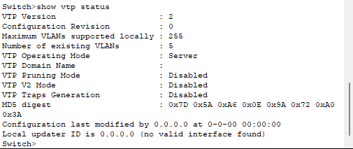

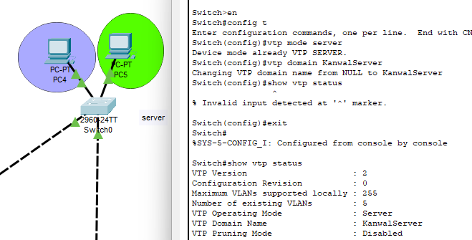

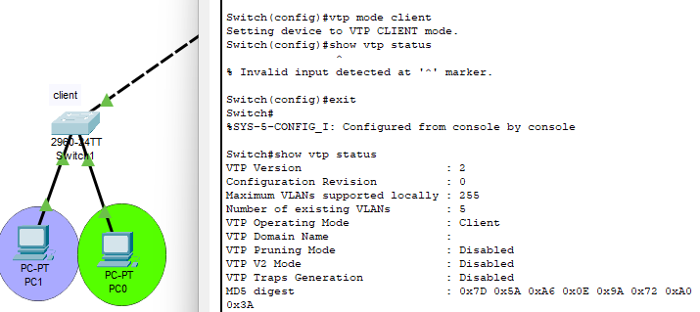

**TRUNKING**

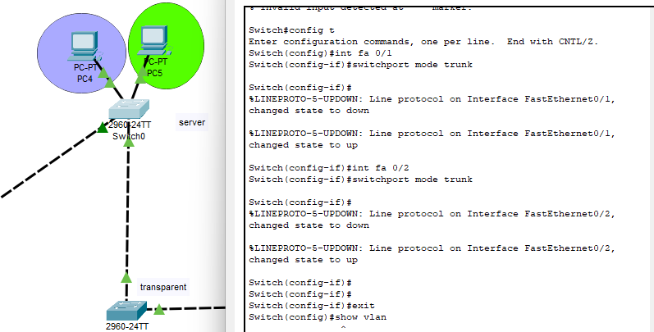

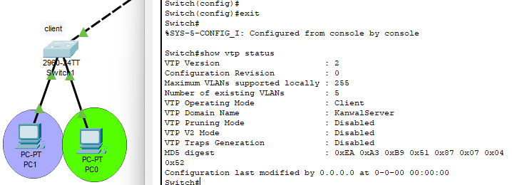

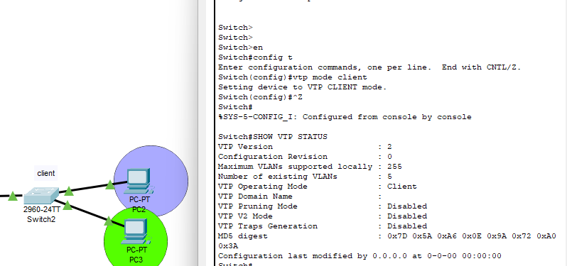

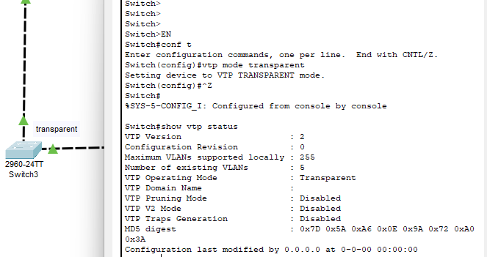

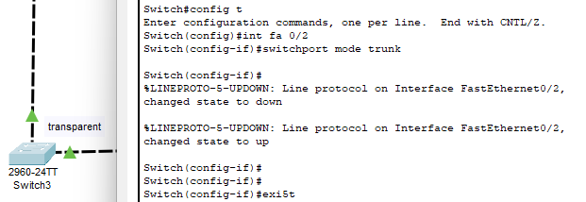

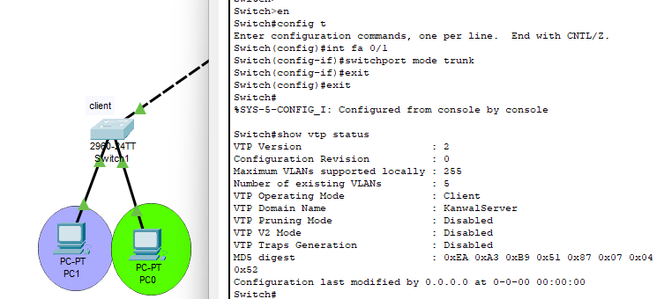

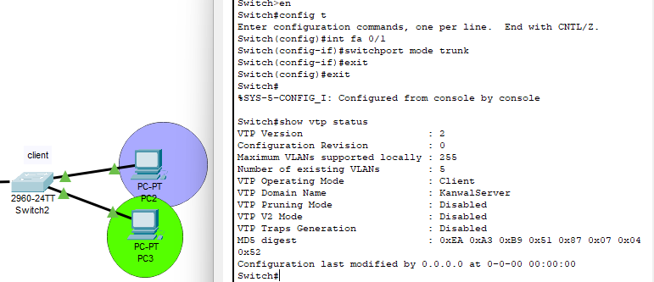

**SETTING UP VLANS IN THE SERVER**

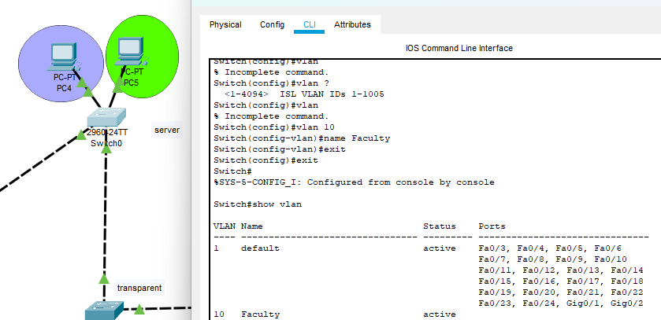

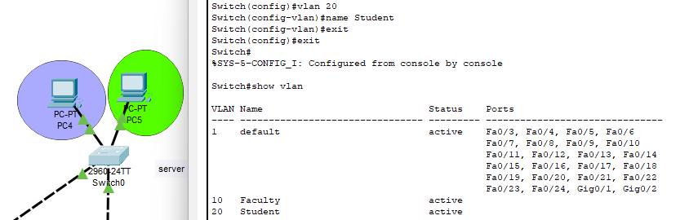

**SERVER VLAN SHOULD APPEAR IN THE CLIENT**

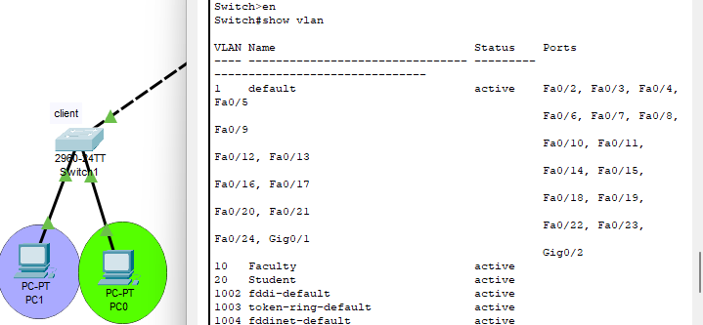

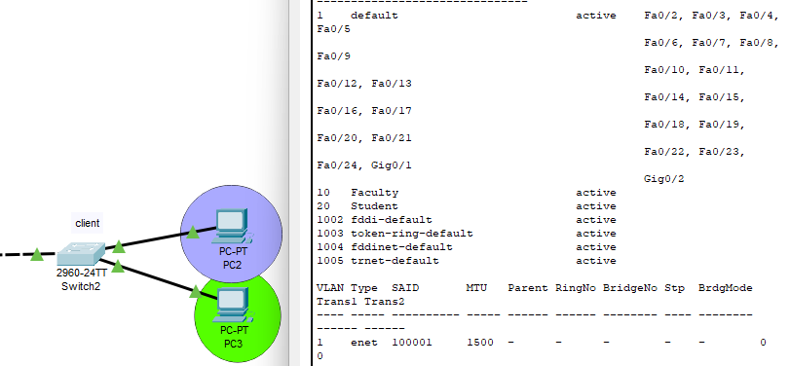

**No vlans in transparemnt as discussed**

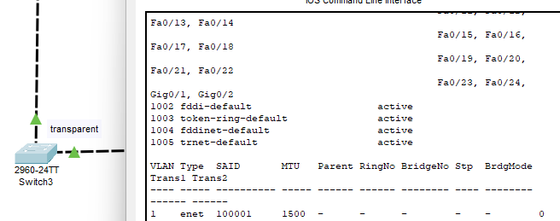

**Interfacing All Switches With Ports**

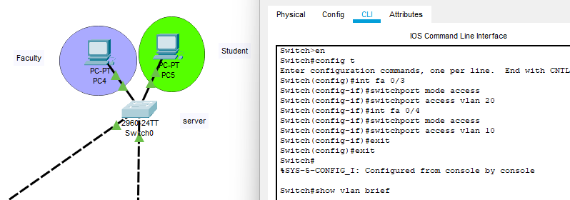

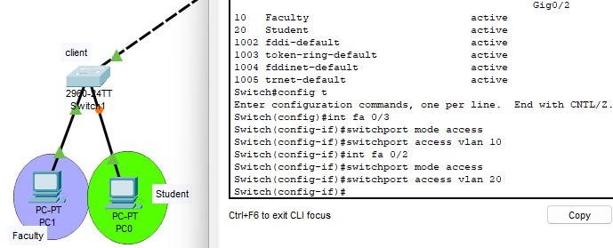

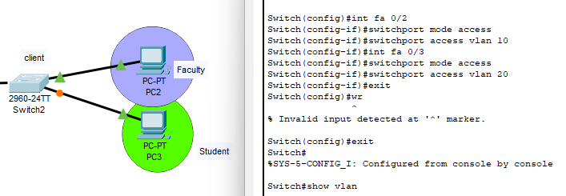

**Pinging**

**Client1(Fac) → Server(Fac) ping**

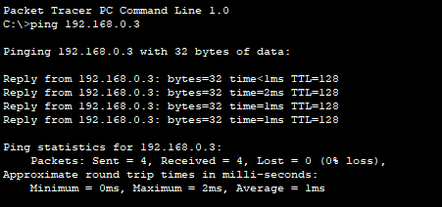

**Client1(stud)→ Client1(fac) Failed**

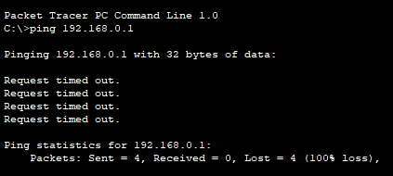

**Server(Student) → Client1(Student) Ping**

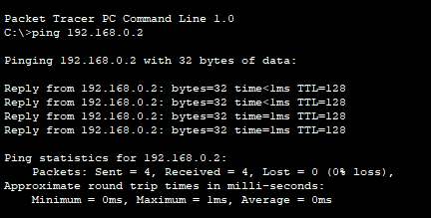

**Anywhere → Client2 Failed**

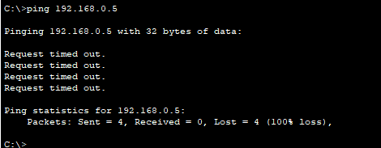

|  |  |  |
| --- | --- | --- |
| **FROM** | **TO** |  |
| 192.168.0.1 | 192.168.0.3 | Ping |
| 192.168.0.2 | 192.168.0.1 | Failed |
| 192.168.0.4 | 192.168.0.2 | Ping |
| 192.168.0.4 | 192.168.0.5 | Failed |